Advanced Games Programming
Tutorial 08 - Additional Exercises

Extra

Name Extra exercises Tutorial xx Extra yy, using appropriate xx and yy.

Extra Exercise 01

This exercise will look at adding a second texture and applying it to your object. This is called multi-texturing.

- Create a new project based on Tutorial 08 Exercise 02.
- Add a second global shader resource view for a texture, called g_pTexture1.
- Create a second bitmap in your assets folder.
- Just after loading the first texture, load this second texture into g_pTexture1.
- Set this texture as the second texture just after the first in RenderFrame():

Remember, the first texture was put into slot 0, so this one goes into slot 1.
- Don't forget to Release() the texture during program shutdown.
- In the shader file, add a second Texture2D called texture1.
- In the pixel shader use texture1.Sample(sampler0, texcoord)to sample the second texture, and multiply this with the sample from the first. Note that this second sample uses the same sampler and texture coordinates as the first.
- You should find the images superimposed on each other. (It may be difficult to see if both textures are dark, in this case try adding the samples together before multiplying with the colour.)

Extra Exercise 02

Create your own font texture, and load it in addition to the one provided. Display both on screen at the same time.

Extra Exercise 03

Modify the texture to include symbols, e.g. space, $,%,&, etc. Add code to the Text2D class to correctly interpret and display these symbols.

Extra Exercise 04

A more pleasing effect for text display is if the background of the texture is transparent, you will need to use a different format such as .png for this. You will also need to turn on the alpha blending state of the renderer, this allow transparency for textures. The alpha channel of the texture will represent how transparent a texel is, with 0 being completely invisible.
- Create a new bitmap with the non-text areas set to be transparent.
- First add two global blend state variables in main.cpp:
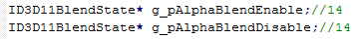
- Next you need to create the blend enable and disable states in InitialiseD3D():
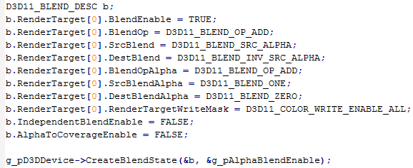
- Load in the new font bitmap (with transparency) in place of the existing one.
- Just before the RenderText() method is called, set the blend mode to enable alpha:
- Disable alpha blending after the text has been drawn.
- Ensure you Release the blend states when the program exits.

You can of course use these blending states to allow you to use transparency with the textures on your objects as well.

Extra Exercise 05

Create another texture that contains patterns instead of letters. Think of how you might use the existing font class to use these patterns to create a user interface. [Advanced] Create a new Sprite class that deals with general 2D texturing.

Advanced

Name advanced exercises Tutorial xx Advanced yy, using appropriate xx and yy.

Advanced Exercise 01

Try different arithmetic operations using the samples and the colour to modify the final output colour.

There are also a large number of intrinsic functions that are available in HLSL that can be used in your pixel shader, a full list is here:

http://msdn.microsoft.com/en-us/library/windows/desktop/ff471376(v=VS.85).aspx

Note that some of these won't be applicable to pixel shaders, or the type of rendering you have set up, so read the descriptions carefully. Try some of these in order to modify the output in interesting ways.
Remember you can also modify each individual colour component by using the .rgba selector syntax, e.g.:

would set the red component of the samples to 1.0.
You can also play with the texture coordinates before sampling, for instance by passing in more shader constants that control the offset of the texture, i.e. move the texture coordinates up, down, left and right, or you could scale the coordinates, which would look like zooming in and out. You can of course modify the texture coordinates using the arithmetic operators and intrinsic functions, just like with the samples, this code, for example:

is modifying the x coordinate of the coordinates using the blue component of the texture 0 sample. If you then sampled texture 1 using the new coordinates this will give pretty strange rendering results generally, but shows how flexible and powerful HLSL is.

Advanced Exercise 02

Update the font system to allow variable width fonts.

Advanced Exercise 03

Update the font system to add colour. You will need to specify a colour in the AddText() method, then upload that colour as a pixel shader constant. Use the constant shader colour in the pixel shader to modify the output colour.

